Gavi learning Agenda
Lessons from the Pilot implementation of free human rabies vaccines provision through IVD
As part of Gavi's support for the introduction of human rabies vaccines in Tanzania, Côte d'Ivoire, and Chad, a pilot was conducted to generate evidence on the integration of rabies post-exposure prophylaxis (PEP) into routine immunization services. Alongside activities aimed at identifying barriers and facilitators to PEP uptake and strengthening community engagement, free PEP was provided through immunization and vaccine delivery (IVD) services from September to November 2025. To assess the impact of this approach on rabies prevention, we compared key indicators among bite victims during the three months before, during, and after the period of free PEP provision.
Preliminary findings
- Table 1: PEP adherence and completion rates
DISTRICT | Period | Total bites | 1st dose | 2nd dose | 3rd dose | 4th dose | Completion rate (%) | Human death
Arusha | Before | 194 | 113 | 47 | 29 | 5 | 30 | 0
Arusha | During | 322 | 182 | 84 | 50 | 6 | 31 | 0
Arusha | After | 275 | 168 | 68 | 38 | 1 | 23 | 0
Kilosa | Before | 74 | 51 | 20 | 1 | 0 | 2 | 2
Kilosa | During | 130 | 72 | 42 | 16 | 0 | 22 | 0
Kilosa | After | 60 | 41 | 15 | 4 | 0 | 10 | 0

Across both districts, a large number of bite patients initiated PEP, but progressively fewer returned for subsequent doses (Table1). In Arusha, the number of victims who started and completed the vaccination schedules increased from 30% before the pilot to 31% during the period of free vaccine provision, but declined to 23% after free provision ended. A similar pattern was observed in Kilosa, where completion increased from 2.0% before the pilot to 22% during free vaccine provision, before falling to 10% after the intervention ended (Table 1, Figure 1). Although PEP initiation increased during and after the pilot period, completion of the full vaccination course remained suboptimal.
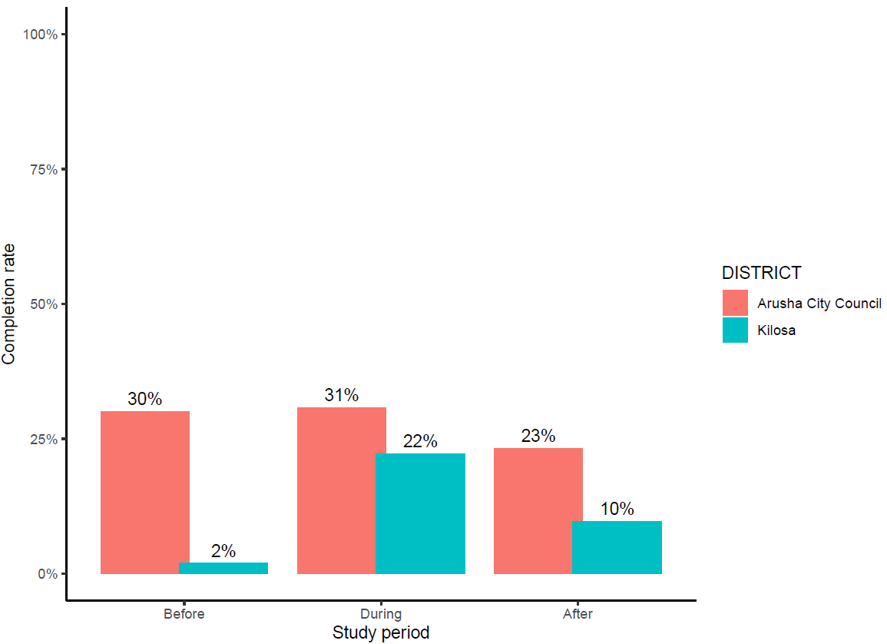
Figure 1: PEP completion rates across the study period comparing the period before, during and after the pilot in the study districts of Arusha and Kilosa.
Changes in bite patient seeking care
The number of bite patients reported increased during the period of free PEP provision in both study districts. In Arusha, reported bite patients increased from 194 before the pilot to 322 during the pilot, representing a 66.0% increase. Similarly, in Kilosa, bite patient reporting increased from 74 to 130 cases, a 75.7% increase. Following the end of free PEP provision, bite patient reporting declined in both districts. In Arusha, reported bites decreased by 14.6%, from 322 during the pilot to 275 after the pilot. The decline was more pronounced in Kilosa, where reported bites decreased by 53.8%, from 130 to 60 cases (Table 1, Figure 2). Despite this reduction, the number of reported bite patients in Arusha remained higher after the pilot than before its implementation.
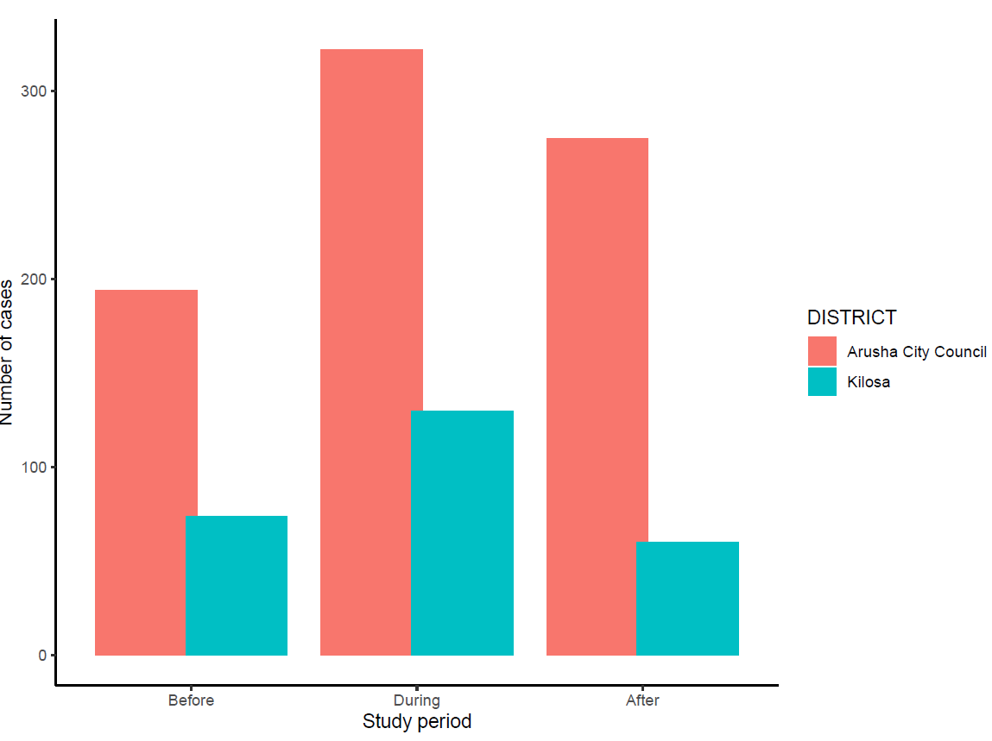
Figure 2: Bite cases reported before, during and after the pilot

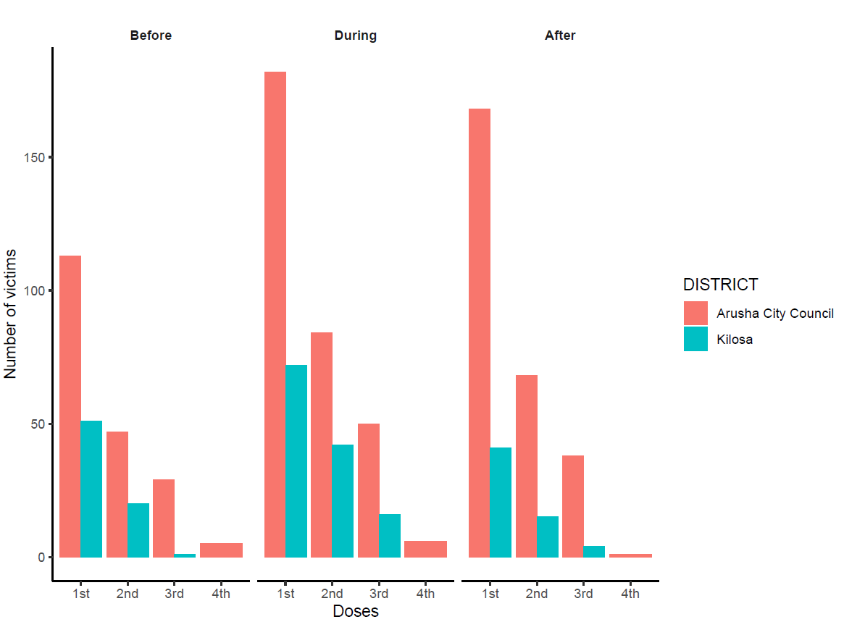
Figure 3: Number of bite patients starting and completing doses

Investigating if bite patients came from neighbouring districts during the pilot period
During the pilot period, Arusha served not only local residents but also bite victims from neighbouring districts. Of the 322 bite patients who sought PEP, 108 (33.5%) resided outside the study district. This suggests that the availability of free PEP attracted patients from surrounding districts where rabies vaccines were either unavailable or difficult to access. In contrast, all 130 bite patients treated in Kilosa were residents of Kilosa district, with no patients seeking PEP from outside districts.

Exploring to see how many people of these that got the 1st dose of human rabies vaccines during the pilot , and were bitten by high risk animals.
During the pilot period, a total of 254 bite patients received the first dose of human rabies vaccine. Of these, 90 (35.4%) (Table 3) had been exposed to animals classified as high risk for rabies based on the outcome of the risk assessments perfumed by health workers. The proportion of bite patients exposed to high-risk animals differed between the two study districts. In Kilosa, 61 of 72 patients (84.7%) receiving a first vaccine dose had been exposed to animals classified as high risk for rabies. In contrast, only 29 of 182 patients (15.9%) initiating PEP in Arusha were exposed to high-risk animals (Table 2).
The observed higher proportion of high-risk exposures among PEP recipients in Kilosa should be interpreted in the context of local implementation practices. During the initial phase of the pilot, rabies vaccines were administered to all bite patients regardless of the health status of the biting animal, and formal risk assessments were not routinely conducted. This approach may have increased the number of patients receiving PEP and influenced the observed distribution of risk categories. Nevertheless, the high proportion of patients classified as having high-risk exposures indicates that a large number of individuals at genuine risk of rabies benefited from access to free PEP. In contrast, a larger proportion of patients receiving PEP in Arusha were exposed to animals assessed as lower risk for rabies, reflecting differences in patient populations, risk assessment practices, or patterns of healthcare-seeking behaviour between the two districts.
Bite patient presentation per 100,000 population
The incidence of bite patients presenting for a first dose of PEP increased during the period of free vaccine provision in both study districts. In Arusha, bite patient presentation increased from 62.5 per 100,000 population before the pilot to 100.7 per 100,000 during the pilot, before declining slightly to 92.9 per 100,000 after the pilot. Similarly, in Kilosa, bite patient presentation increased from 30.4 to 43.0 per 100,000 population during the pilot, before decreasing to 24.5 per 100,000 after free PEP provision ended (Table 2).
The incidence of patients exposed to high-risk animals also increased during the pilot. In Arusha, high-risk bite incidence rose modestly from 14.9 to 16.0 per 100,000 population during the pilot and increased further to 29.3 per 100,000 after the pilot. In Kilosa, high-risk bite incidence increased from 22.7 to 36.4 per 100,000 population during the pilot before declining to 22.1 per 100,000 after the intervention. Throughout the study period, the proportion of bite patients classified as high risk was consistently higher in Kilosa (74.5-90.2%) than in Arusha City Council (15.9-31.5%) (Table 2).
DISTRICT | Period | Bite patients | High risk bites | High risk bites (%) | Bite Incidence per 100,000 persons | High risk incidence per 100,000 persons
Arusha | Before | 113 | 27 | 23.9 | 62.5 | 14.9
Arusha | During | 182 | 29 | 15.9 | 100.7 | 16
Arusha | After | 168 | 53 | 31.5 | 92.9 | 29.3
Kilosa | Before | 51 | 38 | 74.5 | 30.4 | 22.7
Kilosa | During | 72 | 61 | 84.7 | 43 | 36.4
Kilosa | After | 41 | 37 | 90.2 | 24.5 | 22.1
Table 2: Bite patient présentation per 100,000 population

Changes in high risk exposures
The number of bite patients exposed to high-risk animals across the study sites increased from 65 before the pilot to 90 during the period of free PEP provision and remained at 90 after the pilot (Table 3).
Table 3:Change in high-risk exposure incidence during the pilot
Period | Total patients | High risk exposures | Low risk exposures | Percentages of high risk exposures
Before | 164 | 65 | 99 | 39.6
During | 254 | 90 | 164 | 35.4
After | 209 | 90 | 119 | 43.1

Overall, the incidence of high-risk rabies exposures increased during the pilot, although the magnitude of change differed between the two districts. In Arusha, the incidence of high-risk bite patients increased modestly by 7.4%, from 14.9 to 16.0 per 100,000 population during the pilot, before rising further to 29.3 per 100,000 population after the pilot (an 83.1% increase compared with the pilot period). In contrast, Kilosa experienced a 60.4% increase in high-risk bite incidence during the pilot, from 22.7 to 36.4 per 100,000 population, followed by a 39.3% decline after the pilot to 22.1 per 100,000 population (Table 4).
Although the absolute number of patients with high-risk exposures increased during the pilot (65 to 90), the proportion of first-dose recipients classified as high risk decreased from 39.6% before the pilot to 35.4% during the pilot, before increasing to 43.1% after the pilot (Table 3). This reflects a proportionally greater increase in the number of lower-risk bite patients seeking care during the period of free PEP provision.
Table 4; Changes of high risk exposure during and after the pilot period
DISTRICT | Before | During | After | % changes in high risk exposures during the pilot | % changes of high risk exposures after the pilot
Arusha | 14.9 | 16 | 29.3 | 7.4 | 83.1
Kilosa | 22.7 | 36.4 | 22.1 | 60.4 | -39.3

Point to discuss
The impact of free PEP provision differed between the two pilot districts. In Arusha, the incidence of bite patients increased by approximately 61% during the pilot, whereas the incidence of high-risk rabies exposures increased by only 7%. This suggests that removing financial barriers encouraged healthcare-seeking among a broader group of bite victims, including many exposed to animals subsequently assessed as low risk for rabies. Although this may increase vaccine demand, it also provides an opportunity for timely risk assessment, counselling, and discontinuation of unnecessary PEP where appropriate.
In contrast, both overall bite-patient incidence and high-risk bite incidence increased greatly in Kilosa (42% and 60%, respectively), indicating that free PEP primarily improved access for individuals at genuine risk of rabies. This difference likely reflects variations in healthcare-seeking behaviour, local epidemiology, and implementation practices between the two districts, including differences in the application of bite risk assessments during the early phase of the pilot.

